3.CONNECTIVITY PROGRAM FOR PAYROLL SYSTEM

FORM:-

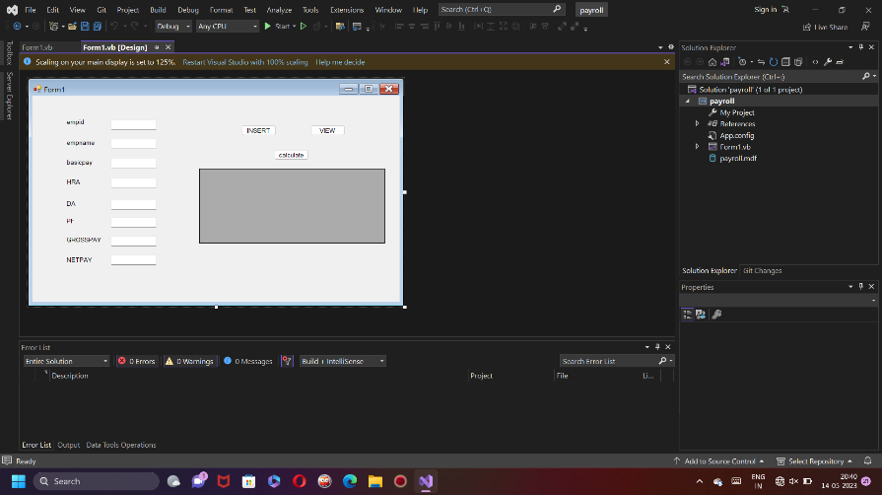

CODE:-

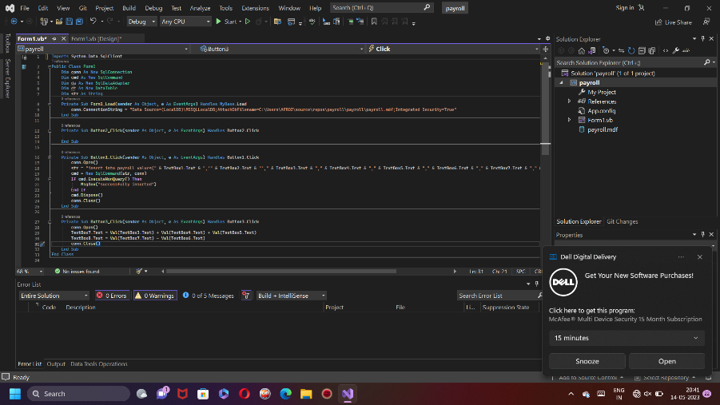

4.CONNECTIVITY PROGRAM FOR STUDENT MARKSHEET

FORM:-

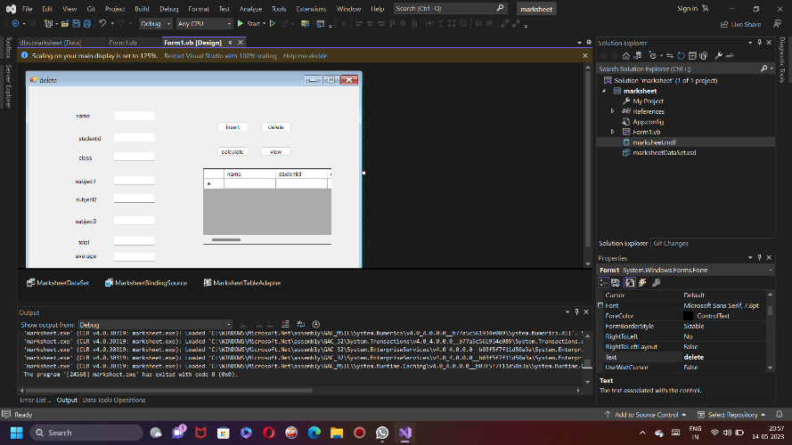

CODE:-

